**LEBANESE AMERICAN UNIVERSITY**

**USAID – HIGHER EDUCATION SCHOLARSHIP PROGRAM**

**HES - Volunteering Program Verification Form**

This form is to be used to document volunteering hours. If a student volunteers for multiple organizations, a separate form must be used for each organization. **This form must be turned in by the 28th of each month, the latest.**

I certify that the scholar Rola saad completed a total of 5 hours of service at Life Sculptor.

The hours were completed hours as per the below:

Hours # 0 (date) _30/09 – 5/10_ (initials of supervisor) __A.K.___

Hours # 0 (date) _7/10 – 11/10_ (initials of supervisor) __A.K.___

Hours # 5 date) _14/10 – 18/10 (initials of supervisor) __A.K.___

Hours # 0 date) _21/10 -25/10 (initials of supervisor) __A.K.___

Brief description of the activities the scholar performed or participated in:

Bundle #52   
Research Topic: The Influence of Culture on Learning Styles. Research about the following key points in detail:   
1. Overview of cultural influences on education.   
2. Impact of cultural backgrounds on learning preferences.   
3. Case studies of culturally responsive teaching methods.   
4. Role of language in shaping learning styles.   
5. Challenges in accommodating diverse learning styles.   
6. Future trends in culturally inclusive education.   
7. Importance of understanding students’ cultural contexts.   
8. Strategies for teachers to incorporate cultural relevance in curricula.   
9. Role of community involvement in education.   
PowerPoint Task: After completing the research task, prepare a PowerPoint presentation summarizing your findings.   
Third task: Develop 8 workshop ideas focused on promoting cultural awareness in education.

Written feedback about the scholar’s performance:

Rola’s comprehensive research on cultural influences in education presents a well-rounded exploration of diverse learning styles. Her analysis provides educators with practical strategies for creating culturally inclusive curricula that foster engagement and inclusivity in the classroom.

Please rate the overall performance of the scholar at your organization:

|  |  |  |  |
| --- | --- | --- | --- |
|  | Mastery (5) | Proficient (3) | Emerging (1) |
| **Problem solver** | X |  |  |
| **Engaged & Committed** | X |  |  |
| **Open-minded & multicultural** | X |  |  |

Signature

& stamp

__________________________

_

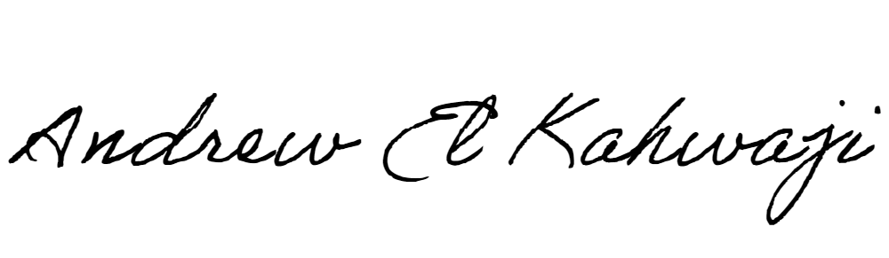

Printed Name _Andrew El Kahwaji_

Date __26/10/2024___

Email __andrew.lifesculptor.coo@gmail.com __

Phone __+961 71 914 378__

**LEBANESE AMERICAN UNIVERSITY**

**USAID – HIGHER EDUCATION SCHOLARSHIP PROGRAM**

